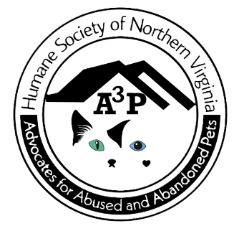

Humane Society of Northern Virginia
powered by
Advocates for Abused and Abandoned Pets (A3P)
Tribute
Honor your family member, friend, or pet with a special donation in their name.
I am enclosing my gift donation of

$25___ $50___ $100___ $250___ Other $____

My bequest is in honor of:
Person:_______________________
Pet: _________________________
Message:________________________________________________________
________________________________________________________________

My bequest is in memory of:
Person:_______________________
Pet: _________________________
Message:________________________________________________________
________________________________________________________________

Please send an acknowledgement to:
Name: __________________________________
Address: _________________________________
_________________________________________
Please send this form and your donation to:
A3P
PO Box 36
Thornburg, VA 22565
All donations are tax deductible
EIN: 82-2554833

