Benefits of Martingale Collars

- Ideal for all sizes and breeds especially dogs with a larger neck than their head.
- No slip design reduces the chance of a dog backing out of the collar.
- Humane tightening action evenly distributes pressure when the collar tightens, increasing control with strong pullers.
- The looser fit will not catch on the fur of breeds with long coats reducing knotted fur around the collar.

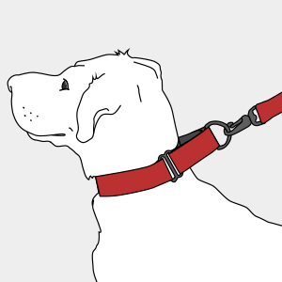 Martingale collars are designed with two parts. A section of a flat collar and a control loop where the leash is attached to a D-ring, which tightens when pulled. This limited-slip collar was originally marketed for sighthounds as their large necks and smaller heads easily enabled them to escape traditional style collars. The tightening action of a martingale collar evenly distributes pressure around the neck and prevents the dog from backing out of the collar.

How to Measure for a Martingale Collar

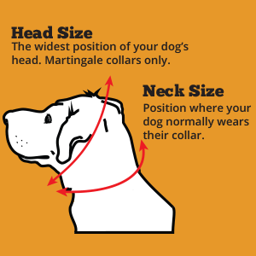

Step 1 - Measure Dog's Neck: Using a soft tape (seamstress tape) measure around your dog’s neck where their collar naturally sits. Pull the tape until it is snug but not tight. You should be able to comfortably put two fingers between the measuring tape and your dog's neck. Record your measurement.
If you do not have a soft tape, use a piece of string and measure around your dog’s neck using the above instructions. Take the string and lay it flat on a smooth surface and use a ruler or tape measure to obtain the measurement.
Step 2 - Measure Dog's Head: If you are ordering a standard martingale (without a buckle) the collar will need to be large enough to fit the neck, but also large enough to fit over the head and ears. Using the same method from step 1, measure the head starting at the throat and going around the head, including the ears.
Record the measurement and use it while determining the correct size collar to order. You will need to find the corresponding size of collar that will fit both the head measurement as well as the neck measurement (if buckle is not added).
Typical Collar Sizes from Dog Head and Neck Measurements
Neck Measurement Collar Measurement Width of Collar
8-11” XS 3/4 inch
11-15” S 3/4 inch
15-22” M 1 or 11/2 inch
19-30” L 1 or 11/2 inch
Generally speaking, you would select a smaller width for a smaller dog, and thicker width for bigger dogs. A wider collar will distribute the pressure across a larger area of your dog’s neck making it more comfortable. There is no right or wrong answer but think small, medium and large in relation to the size of your dog and the width of the best size collar to order. Strong dogs, heavy pullers or dogs bordering on the next size up we may want to select a wider collar. Small dogs who pull may be better suited to a wider collar so damage to the neck doesn’t occur.

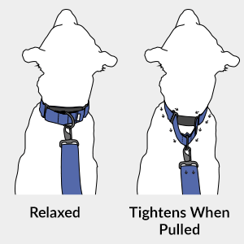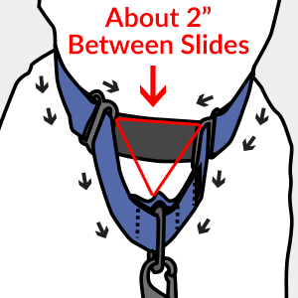
You know you have the correct size collar and it is adjusted correctly when the control loop on the collar has enough slack to pull into a symmetrical triangular shape when a leash is attached and pulled.
If the hardware at the base of the loop is touching, your collar is too loose. It will form a sharp triangle.
If the loop is lying flat against the dog’s neck or forming a flat triangle, the collar is too tight.
Once tension is relieved from the collar it should sit comfortably mid-neck and be slightly looser fitting than a flat collar. When in this location, leash attached, and pulled tight the hardware on the control loop should never touch! There should always be two fingers width of fabric between the hardware.

TIPS and Cautions Using a Martingale
- Although martingale collars are great for everyday walks, the looser design has a slightly higher chance of becoming caught on objects or during play with other dogs. Some professionals recommend only using martingale collars on walks and using an identification / flat collar on your dog so they always have a form of ID on them. Supervision is recommended.
- Dog’s should never be tethered and left unattended for any period of time while wearing a martingale collar.
- Do not use with a retractable leash with a martingale collar. The constant tension of the leash will engage the martingale control loop.
- Martingale collars should be removed before crating your dog.

