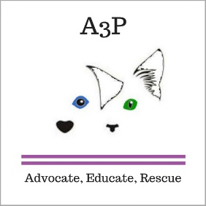

Honor your family member, friend, or pet with a special donation in their name.

I am enclosing my gift donation of

$25___ $50___ $100___ $250___ Other $____

My bequest is in honor of:

Person:_______________________

Pet: _________________________

Message:________________________________________________________

________________________________________________________________

My bequest is in memory of:

Person:_______________________

Pet: _________________________

Message:________________________________________________________

________________________________________________________________

Advocates for Abused and Abandoned Pets

Tribute

Please send an acknowledgement to:

Name: __________________________________

Address: _________________________________  
_________________________________________

Please send this form and your donation to:

A3P

PO Box 36

Thornburg, VA 22565

All donations are tax deductible

EIN: 82-2554833